Senior Project

Design Document

Drop-in Tutoring Web Application

Team Members:

Timothy Baker, Jeremiah Caban, Eric Ray Carpizo, Aanchal Chaturvedi, Huy Ly, Christopher Mariani, and Bryan Nunez

|  |  |
| --- | --- |
| Table of Contents | Page |
| 1. Summary | **3** |
| 1. Technology Stack    1. HTML / CSS    2. JavaScript    3. PHP    4. Java | **4** |
| 1. Application Views | **5** |
| * 1. Home   2. Log In   3. Drop-in Tutoring Schedule   4. Survey/Feedback Form   5. Navigation Bar   6. Tutor Session Logbook   7. Shared Knowledgebase   8. Session Report Page | **5-8** |
| 1. RESTful API | **9-13** |
| 1. Database Design | **14-15** |
| 1. Implementation Plan    1. Features: Log-in, API implementation    2. Views: Home, Log-in, Navigation bar    3. Database instantiation | **16** |

Summary

The group will design and create a web application that will assist various departments with the drop-in tutoring services that they offer. Tutors themselves will be able to log in to access a session logbook, which will help keep track of each individual tutoring session as they take place. They will also have access to a shared knowledgebase for passing back and forth useful information to other tutors as they see fit. Admins, typically a departmental chair or secretary, will be able to log in to view detailed reports of all sessions that have been held over any given period. The system will allow for admins to easily add new tutors or courses to the schedule to keep up with demand as time goes on. Basic features (no login required) will be made available for students, these include: home screen with scrolling news panel, survey/feedback form, and a schedule viewer for the drop-in tutoring services.

Technology Stack

# Bootstrap (HTML / CSS / JavaScript)

The team will utilize the open source Bootstrap framework to build the front-end of the application. Bootstrap is a CDN-accessible library containing predesigned stylesheets as well as JavaScript files.

# PHP

To communicate with the SQL database, the PHP scripting language will be used to perform the backend operations.

# MySQL

A MySQL database will be used for the storage of all data relevant to the application.

# Amazon Web Services

An AWS server will serve as the working environment for which the application will be designed in

Application Views

# Home

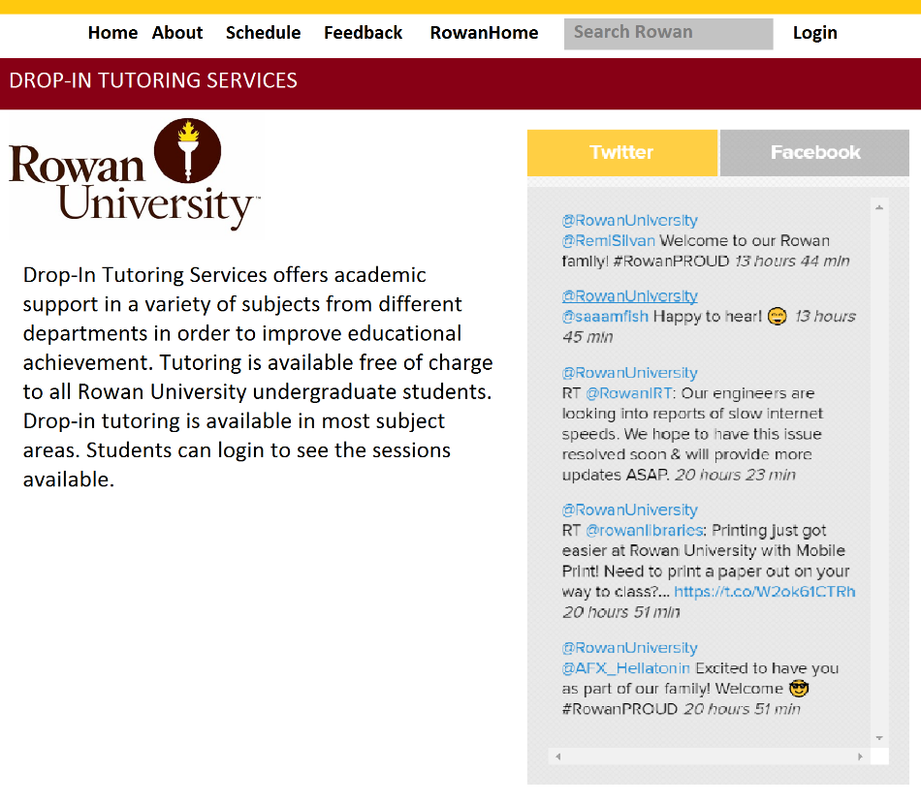

# Log In

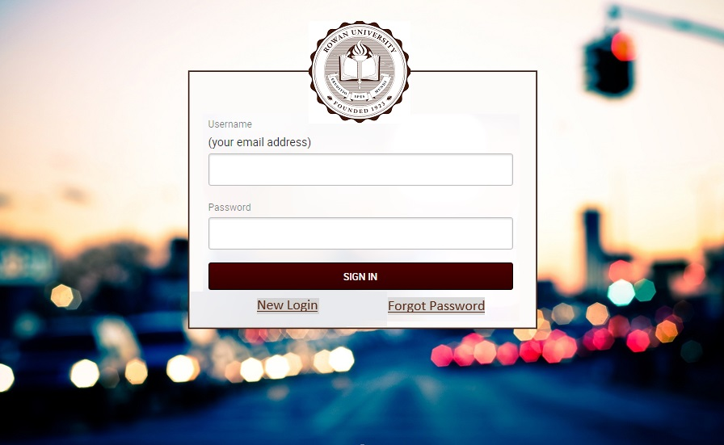

# Drop-in Tutoring Schedule

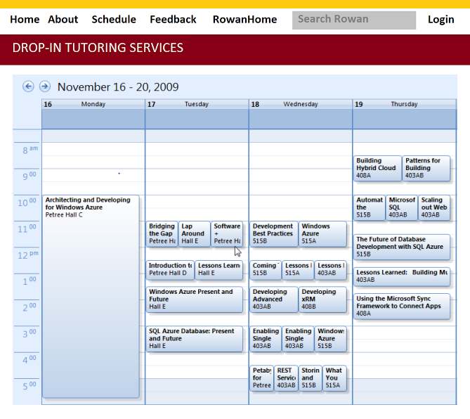

# Survey/Feedback Form

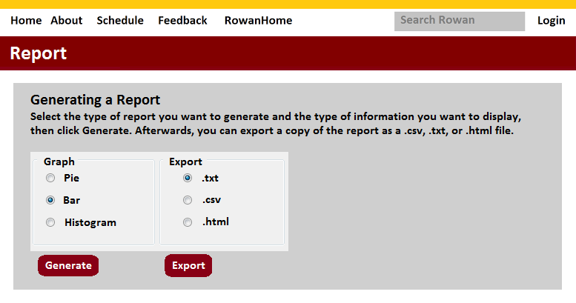

# Navigation Bar



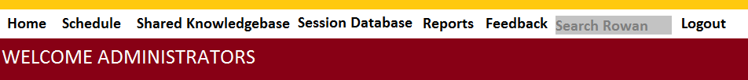

# Tutor Session Logbook



# Shared Knowledgebase

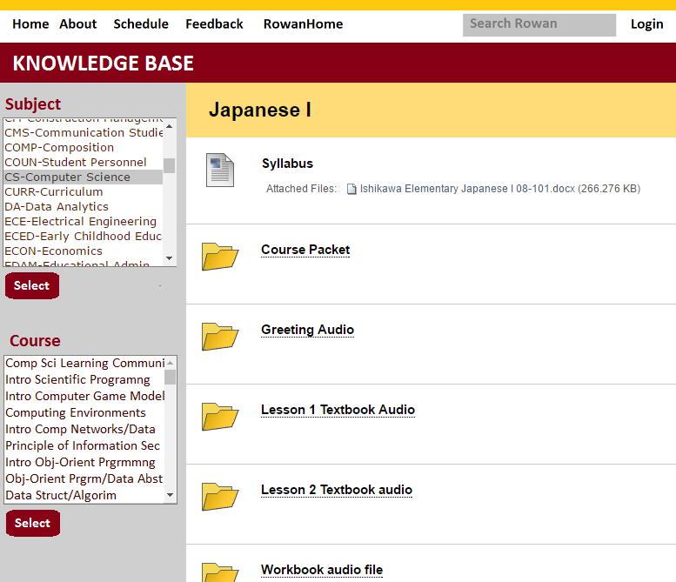

# Session Report Page



RESTful API

**Home**

Endpoint: GET /home/getAnnouncements/:code

Purpose:

Retrieves Announcements for displaying on every end users Homepage. Can return the first 15announcements (if input is zero) or all stored announcements (if input is one).

Input:

code-- path parameter

Output: JSON array of:

announcement-number : Integer

announcement : String

Implementation:

Construct a list from the announcements table starting from the bottom of the table and working up until desired number of announcements is reached (based on input).

Endpoint: POST /home/addAnnouncement

Purpose: Sends an announcement to the database. Functionality is only available to administrative users.

Input:

announcement : HTML POST parameter

Output:

confirmation : boolean

Implementation:

The announcement string will be part of the HTML POST request and be added to announcements table.

**User Login**

Endpoint: GET /users/check/:username

Purpose:

Checks to see if a user exists in the database

Input:

username : path parameter

Output:

confirmation : boolean

Implementation:

Checks the user table to see if the username can be found. Returns true if so and false if not.

Endpoint: GET /users/type/:username

Purpose:

Checks to see if a user is a tutor or admin.

Input:

username : path parameter

Output:

user-type : String

Implementation:

Finds the user in the user table and checks the value of the admin column and then returns the appropriate string.

Endpoint: GET /token/create

Purpose:

Returns a list of courses available

Input:

type : Int (0 for tutor, 1 for admin)

Output:

token : String (to be stored as cookie)

Implementation:

Creates a random token based on type parameter and then stores it on the API server. Send this created cookie back to user.

Endpoint: GET /token/delete

Purpose:

Deletes the currently activated token

Input:

None

Output:

confirmation : Boolean

Implementation:

Takes the current token, finds where it is stored in the API server and removes it.

**Schedule**

Endpoint: GET /courses/getall

Purpose:

Returns a list of courses available

Input:

None

Output: JSON array of:

course-number : Integer

course-name : String

course-department : String

Implementation:

Gets the information from the Course Table in the database, constructs the JSON object

Endpoint: GET /courses/times/:course

Purpose:

Returns a list of times a course is tutored

Input:

course : path parameter

Output: JSON array of:

start time : String

start time : String

Implementation:

Use the course table to identify course ID then use the TimeSlot table’s startTime and endTime columns to create the JSON objects.

Endpoint: GET /courses/getAt

Purpose:

Returns a list of courses available a specified time

Input:

startTime : HTML POST parameter

endTime : HTML POST parameter

Output: JSON array of:

course-name : String

course-location : String

Implementation:

Use the TimeSlot table to identify which course IDs fall within the specified start and end time. Use those course IDs with the Courses table to construct a list of course names.

Endpoint: GET /tutors/getAt

Purpose:

Returns a list of tutors available a specified time

Input:

startTime : HTML POST parameter

endTime : HTML POST parameter

Output: JSON array of:

tutor-name : String

Implementation:

Use the TimeSlot table to identify which course IDs fall within the specified start and end time. Use those course IDs with the TutorTimeSlots table to get userIDs that will be used with the Users Table to get each tutors name.

Endpoint: GET /tutor/available/:tutorname

Purpose:

Returns whether a tutor is currently available.

Input:

tutorname : path parameter

Output:

available : boolean

Implementation:

Use the tutorname with the User’s table to get the tutor’s ID. Then use the tutor’s ID with the TutorTimeSlots Table to get all the timeslot IDs for that tutor. Use the timeslot ID’s with the TimeSlot’s table to see if the current time falls between the startTime or endTime of any of those timeslots.

**SessionLoginTutor**

Endpoint: GET /SessionLoginTUTOR/getCheckedIn/: tutorID

Purpose:

Returns the clocked in status of a tutor as seen from the server.

Input:

tutorID : path parameter

Output:

currentlyActive : boolean

Implementation:

Checks the Tutor Table using a tutors ID to see if they clocked in. A tutor who is currently clocked in returns a true value, and being clocked out returns a false value.

Endpoint: POST /SessionLoginTUTOR/toggleCheckedIn/:tutorID

Purpose:

Input:

tutorID : path parameter

Output:

None

Implementation:

Create a punch card with the tutor ID and add it to the punch card table in the database. Populate time stamp with the current time. Set checked-in to true.

Endpoint: GET /SessionLoginTUTOR/getTutors/:courseID

Purpose:

Returns a list of tutors belonging to a subject.

Input:

courseID : path parameter

Output: JSON array of

firstName : String

lastName : String

Implementation:

Matches a course ID with the Course table and returns a list of User ID’s of entities which tutor the subject.

**SessionLoginAdmin**

Endpoint: GET /SessionLoginADMIN/getCheckins/:

Purpose:

Returns the tutors which have clocked in. Functionality is only available to administrative users.

Input:

None

Output: JSON array of

firstName : String

lastName : String

Implementation:

Constructs a list from the Punch card Table. If any given punch card has its checked-in value set to true, add it to the List.

Endpoint: POST /SessionLoginADMIN/setTime/:punchcardID, timestamp

Purpose :

Sets the time associated with a punch card to another value in case a tutor made an error.

Input:

punchcardID : path parameter

timestamp : path parameter

Output:

None

Implementation:

Match the punch card ID with one available from the Punch card Table. Change the Time stamp associated with the punch card ID.

**Knowledge Base**

Endpoint: GET SessionLoginTutor/KnowledgeBase/getFolders/:

Purpose:

Returns a sorted list of course IDs.

Input:

None

Output: JSON array of

courseName : String

Implementation:

Construct a list of folders and sort them in alphabetical order.

Endpoint: GET SessionLoginTutor/KnowledgeBase/getFile/: fileID

Purpose:

Returns a file from the KnowledgeFiles table.

Input:

fileID : path parameter

Output:

content : Longtext

Implementation:

Match the file ID with one from the Knowledge Files Table. The content is then displayed if it has been approved by an administrator.

Endpoint: GET SessionLoginTutor/KnowledgeBase/getFiles/: courseID

Purpose:

Returns all file ID’s associated with a course ID.

Input:

courseID: path Parameter

Output: JSON array of

fileName : String

Implementation:

Constructs a list of Files from the Knowledge Files table. If any given entry has a corresponding course ID and has been approved, add it to the list.

Endpoint: POST SessionLoginTutor/KnowledgeBase/setFiles/: fileID, contents

Purpose:

Replaces content held in a file.

Input:

fileID : path parameter

contents : path parameter

Output:

None

Implementation:

Matches a file ID with one available in the Knowledge Files table. Content held in the table is then replaced by the content parameter.

Endpoint: POST SessionLoginTutor/KnowledgeBase/addFolder/: courseID

Purpose:

Adds a new course to the knowledge Files table. Functionality is only given to administrators.

Input:

courseID: path parameter

Output:

None

Implementation:

If no instance of the course ID exists in the Knowledge Files table, call addFile and add the file and course ID at the same time.

Endpoint: POST SessionLoginTutor/KnowledgeBase/addFile/: courseID, tutorID, contents

Purpose:

Adds a file to the Knowledgebase Files Table.

Input:

courseID : path parameter

tutorID : path parameter

contents : path parameter

Output:

None

Implementation:

Constructs a new file with the author (a tutor’s) ID. Course ID’s already existing in the Knowledge File Table are the only available options for this field. Tutor ID is populated with the current end-users ID. Once a course ID, tutor ID and contents are submitted to the Knowledge File Table, they are set with an approved value of false and a file ID. An administrator will then have to approve the file contents, which will change the approved value to true.

Endpoint: POST SessionLoginTutor/KnowledgeBase/rm Folder/: courseID

Purpose:

Removes a course ID from the Knowledge File table. Functionality is only given to administrators

Input:

courseID : path parameter

Output:

None

Implementation:

Matches an inputted course id with entities in the Knowledge Files table. Once matched, these entities are removed from the Knowledge Files table.

Endpoint: POST SessionLoginTutor/KnowledgeBase/rm File/: fileID

Purpose:

Removes a file ID from the Knowledge File table.

Input:

fileID: path parameter

Output:

None

Implementation:

Matches an inputted file id to one if the Knowledge File table, if it exists. Once matched, this entity is removed from the Knowledge File Table

**Feedback**

Endpoint: GET /feedback/getSurveys

Purpose:

Returns all the surveys

Input:

None

Output: JSON array of:

cousename: String

tutorname: String

rating: Integer

title: String

comment: String

Implementation:

Use the Survey table to get all required information. coursenames and tutornames are found by using coursed and tutorID with their respective tables. This endpoint will also set the column value of “viewed” to 1

Endpoints: POST /feedback/submitInfo

Purpose:

Allows users to submit a new feedback to the feedback table

Input:

HTML POST parameter

Output:

confirmation : boolean

Implementation:

Takes all the user inputted information in the HTML requests and creates a new entry in the Survey table.

Class Diagram

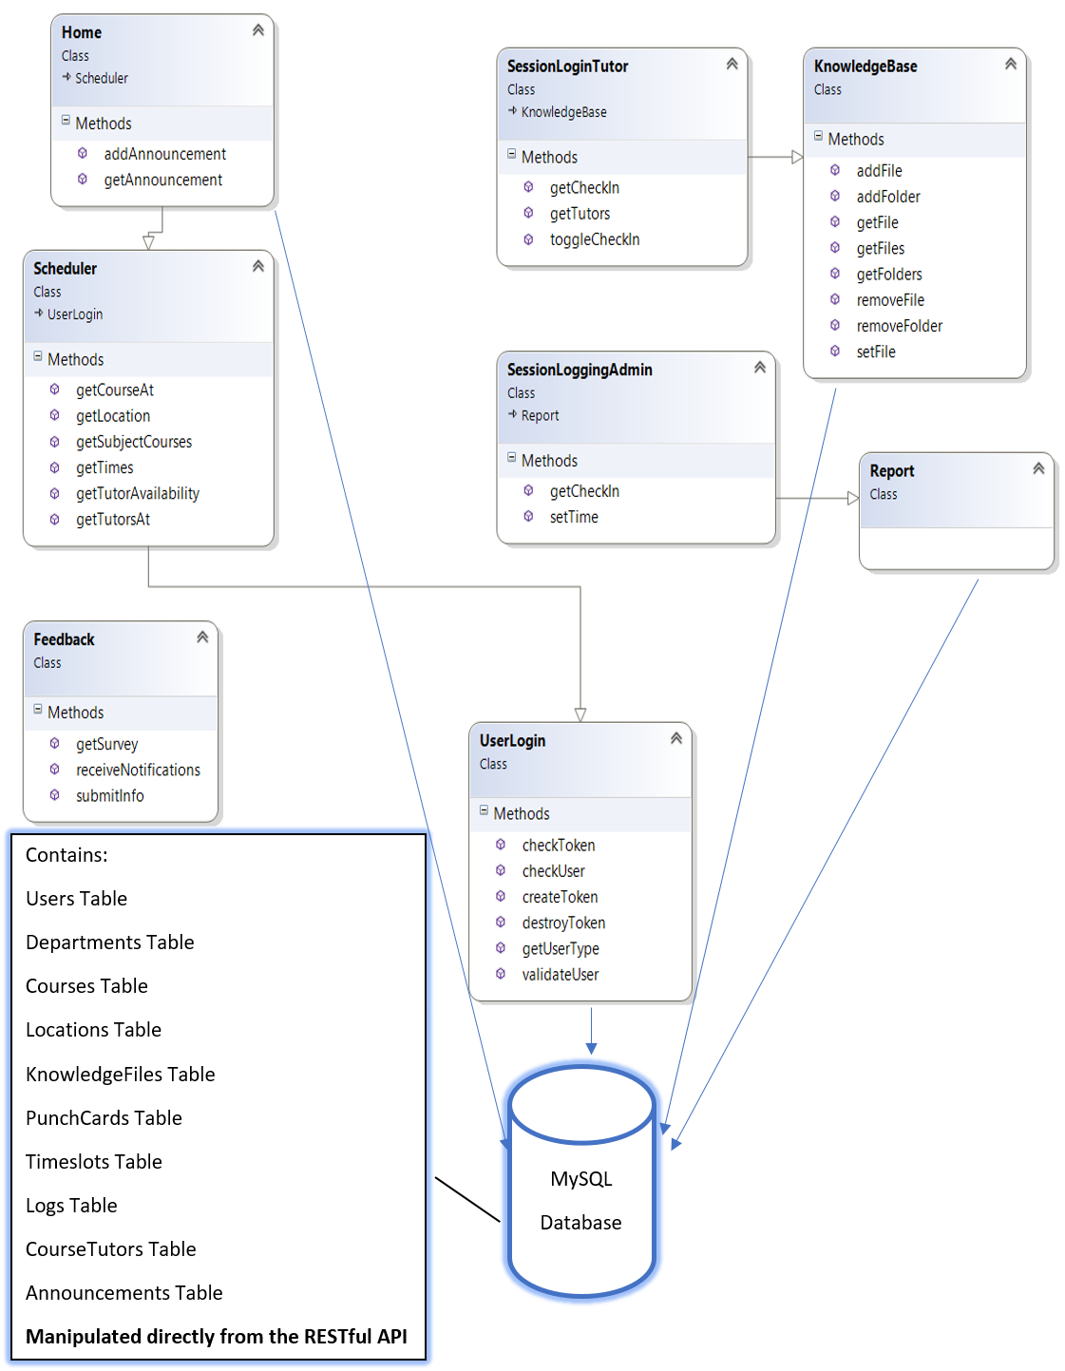

Database Design





Implementation Plan

The team plans on spending the first two weeks generating the front end views of the home screen as well as the log-in page and various navigation bars. With that, the backend team will implement the log-in functionality using the API in order to begin the task of creating the rest of the application.

Features: Log-in, API implementation

Views: Home, Log-in, Navigation bar

Database instantiation